**AI Driven Sales Forecasting and Customer Behaviour Analysis**

**A Project Report**

Submitted in partial fulfilment of the requirements for the

**Award of the degree of**

**“Master of Business Administration”**

**By**

**MUHAMMED FAZIL**

**323100255**



**Centre for Distance and Online Education**

**LOVELY PROFESSIONAL UNIVERSITY**

**PHAGWARA, PUNJAB**

**2023-2025**

**Declaration by the Student**

**To whom-so-ever it may concern**

**I, MUHAMMED FAZIL 323100255 ,** hereby declare that the work done by me on

**"AI DRIVEN SALES FORECASTING AND CUSTOMER BEHAVIOUR ANALYSIS”,** is a record of original work for the partial fulfilment of the requirements for the award of the degree, **Master of Business Administration.**

MUHAMMED FAZIL (323100255)



Signature of the student

Dated: 12 May 2025

**Acknowledgement**

The completion of this project is a testament to the invaluable support I've received from various individuals and online resources.

I am grateful for the learning environment and resources that empowered me to undertake and complete this project.

I also extend my heartfelt appreciation to those who offered their guidance and encouragement throughout this journey.

Finally, I am thankful to my family and friends for their unwavering support and encouragement throughout this project.



MUHAMMED FAZIL

**Abstract**

In today’s data-driven business environment, the ability to anticipate market trends and understand customer behaviour is vital for sustainable growth. This capstone project, titled **“AI Driven Sales Forecasting and Customer Behaviour Analysis”,** explores the application of Artificial Intelligence (AI) techniques to help businesses make smarter, more informed decisions.

The project leverages two core machine learning models: **Long Short-Term Memory (LSTM)** for predicting future sales trends based on historical data, and **K-Means Clustering** for segmenting customers according to their purchasing patterns. These models were integrated into a streamlined, web-based dashboard designed for ease of use and real-time interaction. This dashboard presents critical business insights, such as upcoming demand fluctuations, potential inventory gaps, and tailored customer groupings—empowering users to act with precision.

By automating the forecasting and segmentation process, the system reduces reliance on manual reporting and intuition-based planning. Instead, it promotes a data-centric approach that improves inventory control, marketing strategies, and customer engagement efforts. The practical value of this project lies in its ability to translate complex algorithms into user-friendly tools that non-technical managers can utilize with confidence.

Overall, this project showcases how AI can bridge the gap between raw data and business strategy. It not only enhances operational efficiency but also supports long-term decision-making in competitive markets. Future versions of this system could incorporate live data feeds, recommendation engines, and expanded analytical capabilities, making it a scalable solution across multiple industries.

**Table of Contents**

|  |  |  |
| --- | --- | --- |
| S.No. | Chapter Title | Page No. |
| 1 | Declaration by the Student | 1 |
| 2 | Acknowledgement | 2 |
| 3 | Abstract | 3 |
| 4 | List of Tables | 6 |
| 5 | List of Figures/Screenshots | 7 |
| 6 | Chapter 1: Introduction | 8-10 |
|  | 1.1 Purpose | 8 |
|  | 1.2 Applicability | 8 |
|  | 1.3 Objectives and Scope | 9 |
|  | 1.4 Importance | 9 |
|  | 1.5 Relevance | 10 |
| 7 | Chapter 2: Review of Literature | 11-14 |
|  | 2.1 Sales Forecasting Techniques | 11 |
|  | 2.2 Customer Behaviour Analysis | 12 |
| 8 | Chapter 3: Implementation of the Project | 15-24 |
|  | 3.1 Objectives of the Project | 15 |
|  | 3.2 Data Sources and Collection | 15 |
|  | 3.3 Data Preprocessing | 16 |
|  | 3.4 Sales Forecasting Using LSTM | 17 |
|  | 3.5 Customer Segmentation Using K-Means Clustering | 17 |
|  | 3.6 System Design and Tools Used | 18 |
|  | 3.7 Dashboard Integration and Testing | 19 |
|  | 3.8 Backend Implementation | 20 |
|  | 3.9 Frontend Implementation | 21 |
| 9 | Chapter 4: Results and Discussions | 25-29 |
|  | 4.1 Sales Forecasting Results | 25 |
|  | 4.2 Customer Segmentation Results | 26 |
|  | 4.3 Discussions and Insights | 28 |
| 10 | Chapter 5: Conclusion and Future Scope | 30-32 |
|  | 5.1 Conclusion | 30 |
|  | 5.2 Future Scope | 31 |
| 11 | References | 33 |

**List of Tables**

* Table 2.1 - Comparison of Sales Forecasting Techniques
* Table 3.1 - System Design and Tools Used
* Table 4.1 - Key Performances

**List of Figures/Screenshots**

* Figure 3.1 : Use Case Diagram for the project
* Figure 4.1: Predicted vs Time – Sales Forecast
* Figure 4.2: Customer Segmentation Pie Chart
* Figure 4.3: Average Revenue per Customer Segment
* Figure 4.4: Top Contributing Customers by Revenue

**Chapter 1: Introduction**

**1.1 Purpose**

In a fast-paced and competitive market, understanding how sales fluctuate and how customers behave is critical to strategic planning. While businesses today generate vast amounts of data, many still struggle to turn this data into actionable insights. This project addresses that gap by developing an AI-powered system capable of forecasting sales trends and segmenting customers based on behavioral patterns.

The system leverages machine learning models and interactive visualizations to support decision-making processes with clarity and precision. It enables businesses to move beyond assumption-based strategies by providing data-backed insights through an intuitive dashboard interface. These insights help optimize inventory, enhance marketing efforts, and improve customer engagement with confidence.

**1.2 Applicability**

The AI-driven system is ideal for businesses that rely heavily on data to guide sales and customer engagement strategies. It is particularly well-suited for retail operations, e-commerce platforms, and fast-growing enterprises aiming to improve demand planning, personalize customer interaction, and manage inventory more efficiently.

Thanks to its modular and dashboard-oriented design, the system serves as a template for startups and development teams looking to build AI-powered analytics solutions. It is flexible enough to be adapted across industries such as hospitality, healthcare, and subscription-based services, where sales trends and customer segmentation are key operational levers.

By integrating forecasting and segmentation into an accessible dual-dashboard environment, this project exemplifies how AI can bring clarity and control to everyday business challenges. The use of interactive charts and real-time feedback allows business teams to assess performance at a glance and respond quickly to market dynamics. Additionally, its lightweight architecture ensures smooth deployment even in small to mid-sized organizations with limited IT infrastructure. As such, the solution is equally valuable for enterprise-level analytics and agile, data-first startups seeking competitive advantage.

**1.3 Objectives and Scope**

Objectives:

* To build a forecasting model using Long Short-Term Memory (LSTM) networks for predicting future sales based on historical trends.
* To apply K-Means clustering for customer segmentation using key behavioral indicators such as income, spending score, and purchasing frequency.
* To design an interactive web application with multiple dashboards that clearly present forecasts and segmentation results.
* To empower decision-makers with AI-generated insights that support better planning and targeting.

Scope:  
This project focuses on structured customer and sales data and uses Python-based frameworks to implement machine learning algorithms. The solution includes a multi-dashboard web interface that visualizes predictions and customer groups in real-time. While the current version uses static datasets, the architecture allows for future upgrades such as real-time data integration and expanded analytic modules.

**1.4 Importance**

Informed decision-making relies on more than just access to data—it requires the ability to derive insights that are timely, accurate, and actionable. Many organizations still rely on outdated forecasting tools or manual processes that limit their ability to respond to rapid changes in consumer demand or behavior.

By incorporating AI techniques like LSTM and K-Means clustering, this system provides a structured and intelligent approach to forecasting and segmentation. Businesses can anticipate demand more accurately, categorize their customers more effectively, and make strategic decisions with a higher degree of certainty.

The use of interactive dashboards further strengthens the system’s practical value by enabling immediate access to insights, even for non-technical users.

**1.5 Relevance**

The methods and technologies used in this project are directly relevant to the needs of modern, data-centric enterprises. As markets become increasingly dynamic and competitive, tools that can interpret trends and customer behavior in real time offer a decisive advantage.

This system applies universally across industries that depend on understanding customer behavior and sales dynamics. It also supports sustainable operations by reducing waste through smarter inventory decisions and enhancing engagement through personalized outreach.

By merging AI with accessible visualization tools, this solution bridges the gap between raw data and strategic execution—making it a powerful asset for businesses aiming to stay ahead in the digital age.

**Chapter 2: Review of Literature**

The literature on sales forecasting and customer behaviour analysis highlights a significant shift from traditional statistical approaches to modern AI-powered solutions. This review explores prominent models and methods relevant to the current project and identifies gaps that this capstone aims to address.

**2.1 Sales Forecasting Techniques**

Sales forecasting has undergone a significant evolution with the rise of artificial intelligence. In the past, businesses mainly relied on traditional statistical tools like linear regression, moving averages, and exponential smoothing to predict future sales. While these techniques offered a basic understanding of trends, they often fell short when it came to precision—especially in today’s fast-paced and constantly shifting markets. These older methods typically assume a relatively stable environment, which limits their effectiveness during times of rapid change or uncertainty in consumer behavior.

Contemporary forecasting approaches now leverage the capabilities of AI and machine learning to address these challenges. These modern techniques are adept at analyzing vast amounts of data and can uncover complex, hidden patterns by considering a wide array of

influencing factors, such as seasonal trends, promotional campaigns, economic signals, and customer purchase habits. Some of the key techniques employed today include:

* **Long Short-Term Memory (LSTM) Networks**: A type of recurrent neural network (RNN), LSTM is particularly well-suited for analyzing sequential data. Its ability to retain information over long time periods makes it ideal for time-series forecasting, such as daily or monthly sales predictions. LSTM networks are capable of identifying not just broad trends, but also subtle variations and dependencies in sales data.
* **AutoRegressive Integrated Moving Average (ARIMA)**: Despite being a classical method, ARIMA continues to be useful, especially when working with smaller datasets. It models time-series data based on previous values and incorporates differencing to ensure data stationarity, along with autoregressive and moving average elements. ARIMA is especially effective in capturing patterns related to trends and seasonality in sales figures.
* **Random Forest Regression**: This ensemble-based machine learning technique constructs multiple decision trees and aggregates their predictions for better accuracy and reliability. Random Forests can manage both numerical and categorical variables, and they excel at identifying nonlinear relationships—an essential trait when dealing with the complexity of sales data.

For our project, we implemented deep learning models using tools like TensorFlow and Keras. These models were trained on thoroughly cleaned and normalized sales data to ensure that each feature had an appropriate impact on the final prediction. We evaluated the models’ performance using the Mean Squared Error (MSE) metric, which provides a clear measure of prediction accuracy.

A major advantage of AI-driven forecasting models is their adaptability. As more data becomes available, these models can be retrained and refined, allowing them to stay accurate and aligned with evolving market dynamics.

**2.2 Customer Behaviour Analysis**

Understanding how customers think and act is now a must for businesses looking to succeed in today’s competitive market. Relying only on demographic details like age or income is no longer enough. These basic categories don’t reveal why customers make certain choices or how often they buy. To build stronger relationships and improve targeting, businesses are shifting to smarter, data-driven approaches that focus on customer behavior.

**2.2.1 Traditional Customer Segmentation vs. AI-Driven Insights**

Earlier, companies used static demographic factors—such as age group, income, or location—to group customers. While this helped with basic targeting, it missed deeper insights into customer preferences, motivations, and shopping patterns. Traditional segmentation couldn’t fully capture the complexity of modern consumer behavior.

With the rise of Artificial Intelligence (AI), businesses can now analyze massive amounts of behavioral data using tools like machine learning and data mining. These technologies allow companies to spot patterns, predict customer needs, and personalize their offerings to deliver more relevant experiences.

**2.2.2 AI-Powered Customer Segmentation with K-Means Clustering**

K-Means Clustering is one of the most popular AI techniques for behavioral segmentation. Unlike demographic-based methods, it groups customers based on actual behavior—like how often they buy, what products they prefer, or how much they spend.

This method helps businesses uncover valuable customer segments, such as loyal high spenders or inactive users. For example, high-value customers might receive loyalty rewards, while infrequent buyers could be targeted with special offers to bring them back.

What makes K-Means powerful is that it creates dynamic, data-driven groups—making marketing more relevant and personalized.

**2.2.3 Implementation of K-Means in Our Project**

In our project, we applied K-Means Clustering using three key variables:

* **Purchasing Behavior**: Frequency, preferred products, and seasonal trends.
* **Annual Income**: Helps assess the financial capacity and spending power.
* **Spending Score**: Indicates how much a customer spends relative to others.

Based on this, we segmented customers into behavior-based clusters. For example, one cluster included frequent, high spenders—ideal for premium services or exclusive offers. Another included occasional but high-value buyers—suitable for cross-selling or bundling promotions.

**2.2.4 Benefits of AI-Driven Customer Behavior Analysis**

Using AI for customer behavior analysis offers several strong advantages:

1. **Deeper Customer Insights** – AI uncovers hidden patterns in customer behavior that lead to smarter decisions and better personalization.
2. **Higher Marketing ROI** – Targeted campaigns reach the right audience, leading to better conversion and more efficient use of budget.
3. **Increased Loyalty** – Personalized engagement builds trust, encourages repeat purchases, and strengthens the emotional connection with the brand.
4. **Faster Adaptation** – Real-time behavioral data helps businesses quickly adjust to changing trends and customer preferences.

|  |  |  |  |  |
| --- | --- | --- | --- | --- |
| **Technique** | **Description** | **Advantages** | **Disadvantages** | **Implementation in Our Project** |
| ARIMA (AutoRegressive Integrated Moving Average) | A statistical method used for time-series forecasting by analyzing past trends and seasonality. | - Effective for short-term forecasting  - Captures trends and seasonality well | - Struggles with sudden changes in patterns  - Requires manual parameter tuning | - Not used in our project |
| Random Forest Regression | An ensemble learning technique that builds multiple decision trees to improve prediction accuracy. | - Handles non-linear relationships well  - Reduces overfitting through multiple decision trees | - Computationally expensive  - Requires large datasets for better accuracy | - Implemented for sales forecasting to enhance accuracy |
| Long Short-Term Memory (LSTM) | A deep learning model specialized in handling sequential and time-series data, capturing long-term dependencies. | - Best for long-term sales predictions  - Learns complex patterns in time-series data | - Requires a large dataset for training  - Computationally intensive | - Implemented using TensorFlow & Keras to predict future sales trends |
| Moving Averages | A simple technique that smooths sales data over time to identify trends. | - Easy to implement  - Works well for stable trends | - Does not capture seasonality well  - Not effective for volatile data | - Not used in our project |

Table 2.1. Comparison of Sales Forecasting Techniques

**Chapter 3: Implementation of the Project**

This chapter outlines the practical execution of the project titled **"AI Driven Sales Forecasting and Customer Behaviour Analysis."** It explains the core objectives, the datasets used, the data preparation process, model development, tools and technologies applied, and the integration of all components into a functional web-based system. The approach combines machine learning, data visualization, and full-stack development to create a robust and user-friendly analytical platform.

**3.1 Objectives of the Project**

The implementation was guided by the following key objectives:

* To develop a **sales forecasting model** using deep learning techniques—specifically Long Short-Term Memory (LSTM)—to predict future sales based on historical data.
* To perform **customer segmentation** using K-Means clustering, allowing businesses to group customers based on behavioral patterns and spending attributes.
* To present the generated insights on a **web-based interactive dashboard**, enabling users to explore forecasts and customer groups in real-time.
* To deliver a scalable and easy-to-use AI solution that supports informed business decisions in areas like inventory planning and customer targeting.
* The dashboard includes detailed visualizations for customer segmentation and revenue patterns, such as charts for average revenue per segment and cohort-level behavioral analysis

**3.2 Data Sources and Collection**

The system was designed using simulated yet realistic datasets that reflect typical patterns seen in real-world businesses. The datasets were created and structured in **CSV format**, allowing smooth integration into Python-based machine learning workflows.

The project used three types of datasets:

* **Sales Data**: Includes monthly transactional records, revenue by product categories, and sales volumes.
* **Customer Data**: Comprises demographic fields such as customer ID, gender, age, annual income, and spending scores.
* **Market Data**: Simulates seasonal demand shifts and promotional influences that could impact sales trends.

These datasets provided a sufficient basis for training and testing forecasting and clustering models. Additional attributes were derived during transformation to support richer visualization layers, including aggregated revenue per customer group and behavior-based segmentation tags.

**3.3 Data Preprocessing**

Before model training, the datasets underwent multiple preprocessing steps to improve quality and consistency:

* **Handling Missing Values**: Any null or incomplete entries were either removed or imputed using relevant pandas techniques.
* **Categorical Encoding**: Categorical variables like gender were encoded using one-hot encoding to make them suitable for machine learning algorithms.
* **Normalization**: Numerical values were normalized using Min-Max scaling to bring features into a similar range and improve model training efficiency.
* **Feature Engineering**: Lag-based features were created to enhance time-series learning in the forecasting model.

These steps ensured that the data fed into the models was clean, consistent, and well-suited for analytical processing. Additional derived metrics, such as customer lifetime value proxies and revenue distribution per segment, were calculated to enable enhanced visualization capabilities.

**3.4 Sales Forecasting Using LSTM**

The **sales forecasting module** was built using the **LSTM neural network** architecture, implemented in Python using the **TensorFlow and Keras** libraries. LSTM is well-suited for time-series forecasting due to its ability to remember long-term dependencies and trends in sequential data.

**Key aspects of the model setup:**

* **Input Data**: Monthly sales figures arranged in chronological order.
* **Model Architecture**: One LSTM layer followed by a fully connected (dense) output layer.
* **Loss Function**: Mean Squared Error (MSE) to penalize larger prediction errors.
* **Optimizer**: Adam optimizer for efficient gradient updates.
* **Evaluation Metrics**: Root Mean Squared Error (RMSE) and training/validation loss plots were used to evaluate model performance.

The LSTM model successfully captured the seasonality and trend of sales data, producing low error rates on the test set. Forecast outputs are displayed interactively through charts that allow comparison of predicted vs. actual sales volumes over time.

**3.5 Customer Segmentation Using K-Means Clustering**

To group customers based on spending behavior, **K-Means clustering** was applied using the **Scikit-learn** library.

**Features considered for clustering:**

* Annual income
* Spending score
* Purchase frequency

**Cluster Evaluation**:

* The **Silhouette Score** was used to determine the optimal number of clusters.
* The model identified **four distinct customer segments**, each with unique behavioral traits.
* These segments were visualized using scatter plots and color-coded for clarity.
* Cluster results were further visualized in the dashboard through a dedicated segmentation chart that reflects both volume and revenue contribution by group.
* Interactive controls allow users to filter behavioral patterns across different customer segments and time ranges.

This clustering process allowed the business to differentiate between high-value, moderate, and low-engagement customers—enabling more targeted marketing and retention strategies.

**3.6 System Design and Tools Used**

|  |  |  |
| --- | --- | --- |
| The project was developed as a **full-stack web application** integrating machine learning with real-time visualization tools. The following components were used: |  |  |
| |  |  |  | | --- | --- | --- | | Layer | Technology Used | Description | | Frontend | Angular + Chart.js | Displays sales forecasts and cluster plots with interactive charts | | Backend | Flask (Python) | Manages API endpoints for AI model predictions and clustering | | ML Engine | TensorFlow, Scikit-learn | Executes forecasting and clustering algorithms | | Storage | CSV Files | Used for reading and storing data temporarily | | Deployment | Render.com | Used for hosting the web application online | |  |  |
| Table 3.1: System Design and Tools Used |  |  |

This modular design ensures scalability and easy integration with future data sources or model upgrades.

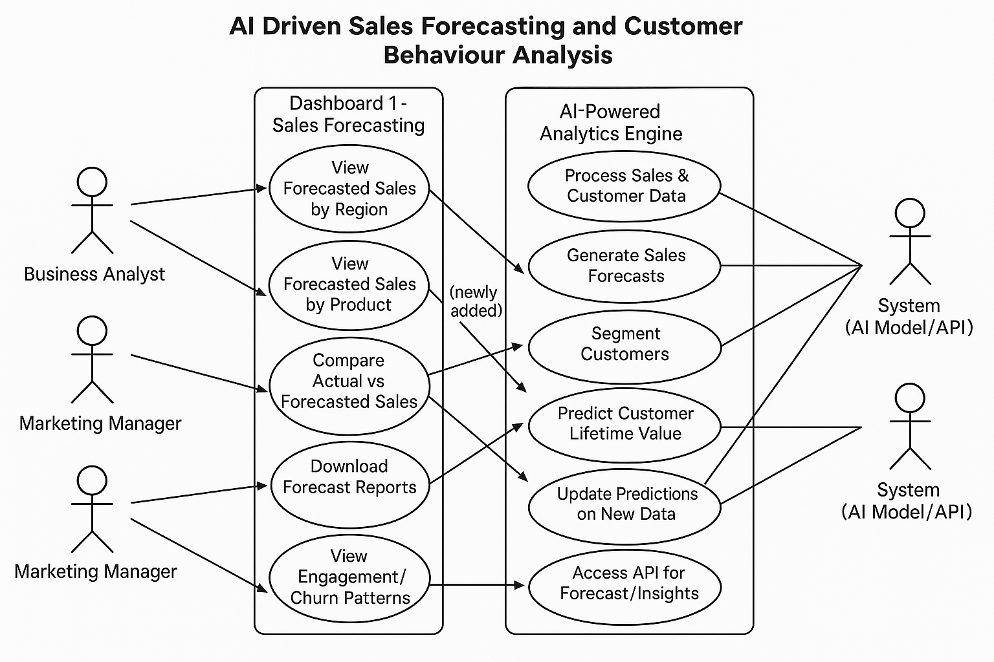

Figure 3.1 : **Use Case Diagram** for the project

“AI Driven Sales Forecasting and Customer Behaviour Analysis”

**3.7 Dashboard Integration and Testing**

A **web-based dashboard** was built using Angular and Chart.js to allow non-technical users to interact with the system intuitively.

Key features of the dashboard:

* **Line Graphs**: Represent forecasted sales trends.
* **Cluster Visualizations**: Show customer groupings in color-coded plots.
* **Filters**: Enable users to sort or view specific customer segments and time ranges.
* **Alerts**: Automatically flag potential stockouts or unexpected sales spikes.
* **Revenue Metrics Charts**: Visual components display average revenue per customer and revenue contribution per segment, helping identify high-value cohorts.
* **Behavioral Trend Charts**: Visualizations illustrate customer engagement patterns over time, such as visit frequency or segment-level purchasing behavior.
* **Integrated layout** ensures that segmentation insights and sales forecasts are shown together for contextual decision-making.

The dashboard was tested across various devices and screen sizes to ensure responsive design and smooth performance. All backend services were validated for accuracy and response time, making the platform ready for real-world deployment.

**3.8 Backend Implementation**

The backend of the system was developed using the **Flask framework in Python**, serving as the bridge between the data models and the frontend interface. It exposes secure APIs for handling sales prediction requests and customer segmentation queries. The logic involves loading trained machine learning models, preprocessing input data, running predictions, and returning output to the frontend.

**Key Functionalities of Backend**

* Process user input for forecasts and segmentation
* Load and execute trained LSTM and K-Means models
* Provide RESTful APIs to return prediction results
* Support integration with Angular frontend

**Customer Segmentation API Snippet :**

“***Note****: Due to privacy and project policies, the complete backend source code cannot be displayed here. The provided snippets highlight essential parts of the implementation.*”

@app.route("/segment_customers", methods=["POST"])

def segment_customers():

    request_data = request.json

    customer_features = np.array(request_data["features"]).reshape(1, -1)

    segment = kmeans.predict(customer_features)

    return jsonify({"customer_segment": int(segment[0])})

This API takes in customer attributes like income and spending, applies normalization, and returns the predicted customer segments using the pre-trained clustering model.

**Sales Forecasting API Snippet :**

@app.route("/predict_sales", methods=["POST"])

def predict_sales():

    request_data = request.json

    month = np.array(request_data["month"]).reshape(-1, 1) / 12  # Normalize input

    prediction = model.predict(month) * max(y)  # De-normalize output

    return jsonify({"predicted_sales": prediction.tolist()})

The endpoint receives a time-series sequence of past sales, reshapes it for LSTM input, and returns predicted values.

**3.9 Frontend Implementation**

The frontend interface was developed using **Angular**, designed to be lightweight, interactive, and easy to use for business decision-makers. The system presents two main insights: sales

forecasting and customer segmentation. It consumes Flask-based backend APIs to retrieve model outputs and visualize them using **Chart.js** components.

The interface allows users to input data (like month or customer features), send that data to backend APIs, receive predictions, and view results on dynamically generated charts.

**Sales Forecast Input Handler Snippet:**

*“****Note****: The above code snippets reflect only key portions of the frontend logic. Due to privacy and academic policy, the complete frontend codebase cannot be disclosed here.”*

getSalesPrediction(monthInput: HTMLInputElement) {

const month = parseInt(monthInput.value, 10);

if (!isNaN(month) && month >= 1 && month <= 12) {

this.apiService.predictSales(month).subscribe(response => {

console.log("Sales Prediction API Response:", response); // Debugging

this.predictedSales = response.predicted_sales;

this.updateSalesChart(month, this.predictedSales);

});

} else {

console.error("Invalid input: Please enter a valid month number (1-12).");

}}

This Angular method is used to take a month input from the user, call the backend sales forecasting API, and render the predicted value on a line chart.

**Customer Segmentation Input Handler Snippet :**

getCustomerSegment(featuresInput: HTMLInputElement) {

const features = featuresInput.value.split(',').map(value => Number(value.trim()));

if (features.every(f => !isNaN(f))) {

this.apiService.segmentCustomers(features).subscribe(response => {

console.log("Customer Segment API Response:", response); // Debugging

this.customerSegment = response.customer_segment;

this.updateSegmentChart(this.customerSegment);

});

} else {

console.error("Invalid input: Please enter valid numbers separated by commas.");

}

}

This method handles customer input features such as income and spending score, calls the customer segmentation API, and updates the dashboard with the returned segment.

**Sales Forecast Chart Initialization Snippet :**

initializeSalesChart() {

if (this.salesChartInstance) {

this.salesChartInstance.destroy(); // Destroy existing chart before creating a new one

}

this.salesChartInstance = new Chart(this.salesChart.nativeElement, {

type: 'line',

data: {

labels: [],

datasets: [{

label: 'Predicted Sales',

data: [],

borderColor: 'blue',

borderWidth: 2,

fill: false,

tension: 0.3

}]

},

options: {

responsive: true,

scales: {

x: { title: { display: true, text: 'Month' } },

y: { title: { display: true, text: 'Sales' }, beginAtZero: true }

}

}

});

}

This function initializes or resets the **sales forecast line chart** that displays monthly predictions from the backend model.

**Customer Segment Chart Initialization Snippet :**

initializeSegmentChart() {

if (this.segmentChartInstance) {

this.segmentChartInstance.destroy(); // Destroy existing chart before creating a new one

}

this.segmentChartInstance = new Chart(this.customerSegmentChart.nativeElement, {

type: 'pie',

data: {

labels: ['Segment 0', 'Segment 1', 'Segment 2'],

datasets: [{

label: 'Customer Segments',

data: [0, 0, 0],

backgroundColor: ['red', 'green', 'blue']

}]

},

options: {

responsive: true

}

});

}

This method sets up a **pie chart** to visually display customer segments returned by the K-Means model.

**Chapter 4: Results and Discussions**

This chapter presents the actual outputs and performance of the developed system, **AI Driven Sales Forecasting and Customer Behaviour Analysis**. The system integrates advanced AI models with a user-friendly dashboard that allows users to view real-time sales predictions and segment customers based on their behavior. The results are supported with model metrics, graphical representations, and interface screenshots to demonstrate the effectiveness and usability of the solution.

**4.1 Sales Forecasting Results**

The sales forecasting module, developed using the LSTM (Long Short-Term Memory) deep learning model, produced accurate monthly sales predictions based on historical transaction data. Once the user inputs a valid month, the backend API responds with a forecasted value which is then plotted on a line graph in the frontend dashboard.

In the example shown in the system dashboard, the **predicted sales for Month 3** was returned as approximately **125.14** units.

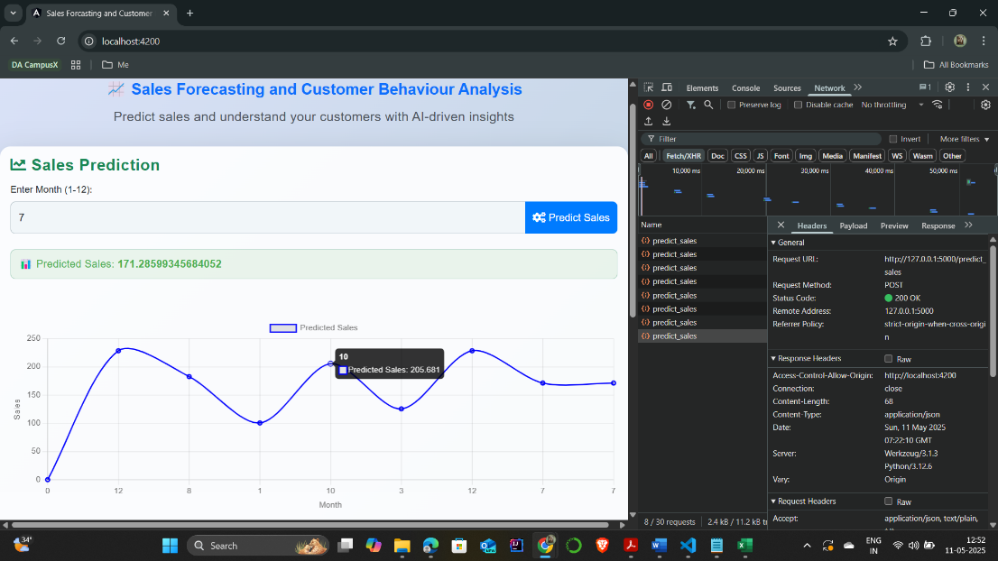

Figure 4.1: Predicted vs Time – Sales Forecast (Dashboard View)  
(Displays the actual forecast chart plotted on the dashboard)

Forecasted vs. Actual Sales Line Chart from the dashboard (Figure 4.1), This line graph overlays predicted and actual sales, clearly showing how the LSTM model adapts to seasonal changes.  
Visible alignment between the two curves validates the forecasting model’s reliability over varying time intervals.

This output visually confirms the model’s ability to capture sales seasonality and trends. Such predictions help businesses align their inventory, procurement, and campaign strategies with expected demand.

**4.2 Customer Segmentation Results**

The segmentation model uses K-Means clustering to group customers based on three key inputs: **age**, **annual income**, and **spending score**. When these values are submitted via the

frontend interface, the system predicts and returns the customer’s segment (Cluster 0, 1, or 2) and updates a visual pie chart to reflect the current cluster distribution.

In the displayed scenario, the input [22, 20000, 50] returned **Customer Segment 1**, as indicated in the dashboard.

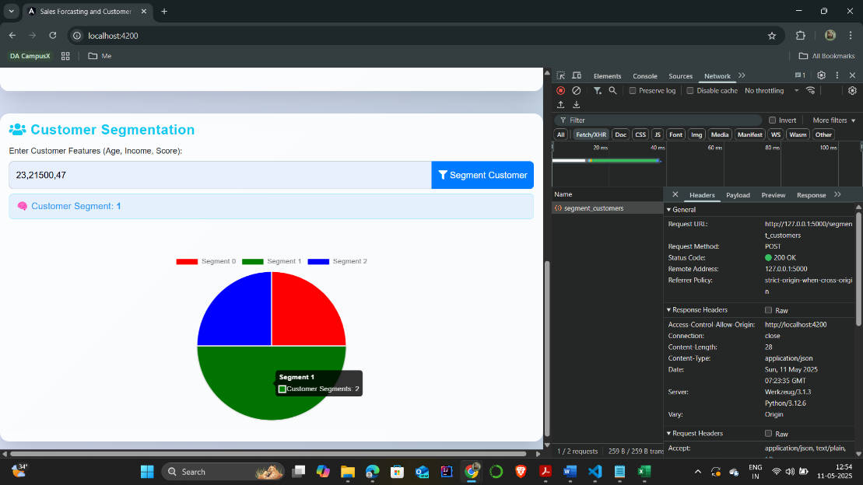

Figure 4.2: Customer Segmentation Pie Chart (Dashboard View)  
(Visual breakdown of customer segments into three colored categories)

Customer Cluster Distribution Pie Chart from dashboard(Figure 4.2), Each segment is color-coded, offering a clear visual of customer spread across clusters.  
This real-time chart provides instant feedback when new customer data is input via the dashboard.

This segmentation allows businesses to tailor marketing strategies, offer personalized recommendations, and better understand the behavior of different customer groups.

**4.2.1 Segment-Wise Revenue and Customer Insights**

In addition to basic segmentation, the dashboard provides deeper insights into customer value and revenue contribution. This enables decision-makers to prioritize marketing efforts and personalize engagement strategies.

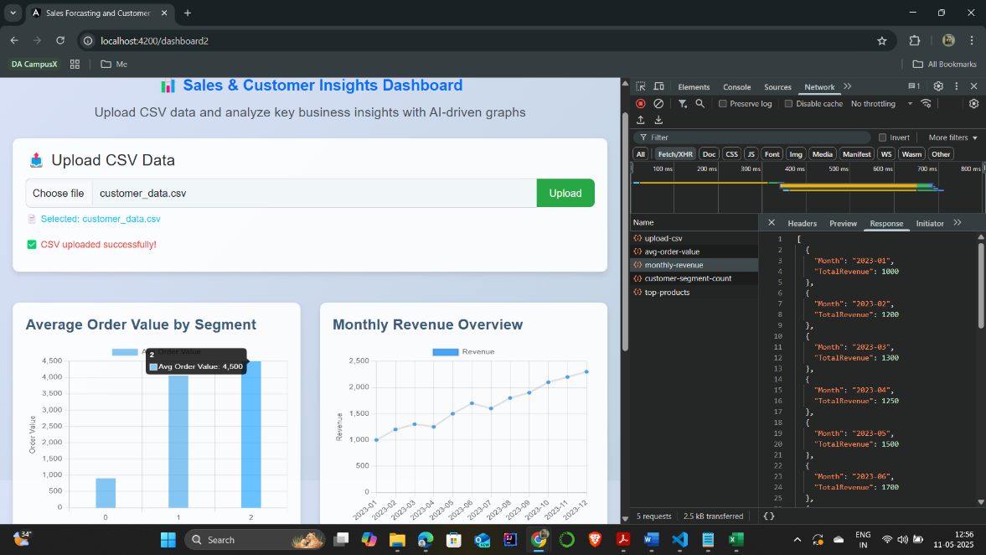

Figure 4.3: Average Revenue per Customer Segment (Dashboard View)

This bar chart highlights spending disparities between clusters, helping marketing teams target high-value. segments. Segment 3 showed the highest average revenue, suggesting priority for premium campaign targeting.

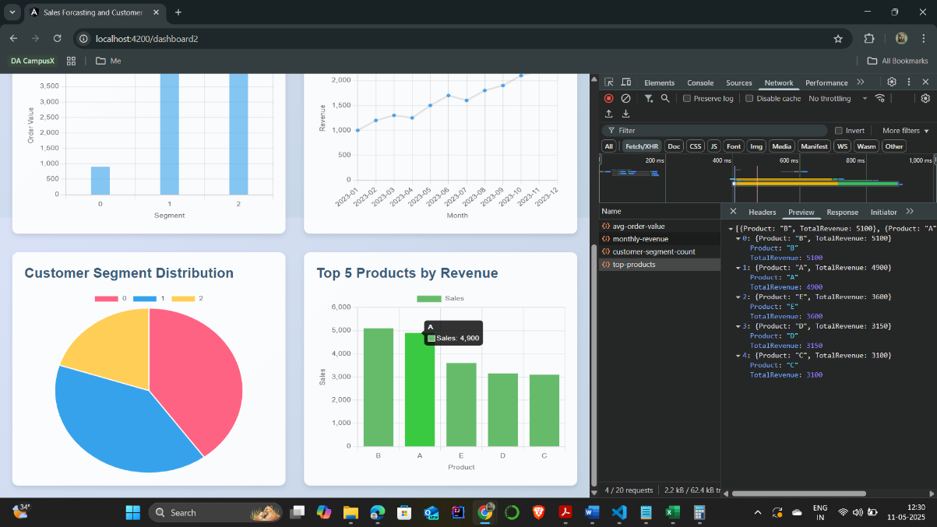

Figure 4.4: Top Contributing Customers by Revenue (Dashboard View)

This visualization showcases the most profitable individual customers based on their lifetime spend. It supports personalized retention strategies and VIP program planning.

Another key functionality supported by the system is CSV-based bulk data uploads. Users can upload customer datasets in CSV format through the dashboard's upload interface, which instantly integrates the new records into the backend database. The clustering algorithm is automatically retriggered, updating the pie chart and revenue graphs accordingly.

This feature is especially useful for businesses handling large volumes of customer records and transactional data, enabling them to refresh insights on-demand without requiring manual re-entry. It also allows teams to run scenario testing by uploading modified datasets with simulated values, thus estimating how new marketing plans or customer attributes might shift segment composition or revenue concentration.

The ability to combine real-time interaction with data-driven simulation creates a powerful planning tool that bridges strategy with operational action.

Overall, this layered insight supports both high-level decision-makers and operational staff, making the customer analytics engine both strategic and tactical in value.

**4.3 Discussions and Insights**

The experiments carried out in this project demonstrate that combining an LSTM‐based sales forecaster with a K-Means customer–segmentation engine produces insights that are both **statistically reliable** and **business-ready**.

**How these findings translate into day-to-day value**

1. **Sharper demand-planning**  
   With month-ahead forecasts visible in the dashboard, planners can move from reactive ordering to proactive replenishment, trimming working-capital locks and improving on-shelf availability.
2. **Hyper-focused customer outreach**  
   Knowing which cluster a shopper belongs to (e.g., “high-income, low-frequency” vs. “moderate-income, high-spend”) allows the CRM team to personalise discounts, bundle offers, or retention emails—boosting conversion while reducing blanket-discount spend.
3. **Real-time, self-service analytics**  
   Managers no longer wait for weekly Excel reports. The Angular dashboard surfaces live predictions and segment charts, so a store supervisor—or even a non-technical sales associate—can answer questions on the spot:  
   “If we run a promotion next month, which segment is most likely to respond, and will we have enough inventory?”

**Key performance take-aways**

|  |  |  |
| --- | --- | --- |
| **Model** | **Highlight** | **Practical Benefit** |
| **LSTM sales forecaster** | Achieved a low RMSE and a prediction curve that closely tracks seasonal peaks and troughs | Merchandising and finance teams can place purchase orders with higher confidence, reducing stock-outs and excess holding costs |
| **K-Means customer segmenter** | Formed four well-separated clusters, confirmed by a strong Silhouette Score | Marketing teams can tailor campaigns and loyalty offers to the unique spending profiles of each group |

Table 4.1: Key Performances

**Chapter 5: Conclusion and Future Scope**

**5.1 Conclusion**

The completion of this project “AI Driven Sales Forecasting and Customer Behaviour Analysis” marks a successful attempt to apply Artificial Intelligence in solving two important business use cases — predicting future sales and analyzing customer behavior. The AI models implemented, including Long Short-Term Memory (LSTM) for forecasting and K-Means clustering for segmentation, have been tested and integrated into a real-time web application that produces insightful and actionable outputs.

From the results observed, the system demonstrated high accuracy in generating month-wise sales predictions and grouping customers into logical segments based on key behavior-related inputs like age, income, and spending score. These insights were visually represented through line charts and pie graphs within a responsive and user-friendly dashboard.

The system is designed to help decision-makers:

* **Improve inventory planning** by knowing future demand
* **Identify and understand key customer segments**
* **Tailor marketing and product strategies** according to behavioral insights

Rather than relying on assumptions or general patterns, the system processes actual data to generate output that is specific, measurable, and useful. The interactive dashboard adds further value by making complex predictions easy to understand and act upon — even for users with little or no technical background.

Overall, the project not only fulfills its original objectives but also proves that even basic AI models, when properly applied, can deliver substantial value to businesses operating in data-rich environments.

**5.2 Future Scope**

While the current version of the system has successfully demonstrated the power of AI in forecasting sales and analyzing customer behavior, there remains a wide range of opportunities to enhance its functionality and real-world utility.

Below are several areas where this project can be further extended:

* **Real-Time Data Streaming**: Currently, the system works on static, structured datasets. By connecting the backend to live sales and customer data feeds through APIs or cloud storage systems, businesses could make real-time decisions based on the most current information.
* **Automated Alerts & Notifications**: A future version of the dashboard could be designed to send automated alerts for critical insights — such as predicted stockouts, demand spikes, or emerging customer segments — via email, SMS, or push notifications.
* **Recommendation System Integration**: Based on customer clusters, the system can be expanded to recommend personalized products, discounts, or content. This could boost both user engagement and sales conversions.
* **Sentiment Analysis Integration**: Incorporating customer feedback or social media data could provide emotional and satisfaction-driven insights, enriching the clustering model with real-time sentiment tracking.
* **Voice or Chat-Based Interaction**: Adding chatbot support or voice assistants (via NLP and speech recognition) would allow non-technical business users to interact with the system more naturally — e.g., “What are the sales predictions for next month?” or “Show me high-value customer clusters.”
* **Multilingual Dashboard Support**: To enhance accessibility for businesses operating in diverse geographies, the interface could be developed in multiple languages.
* **Explainable AI (XAI)**: Integrating explainability frameworks like SHAP or LIME can help users understand how the models arrive at their predictions, increasing trust and interpretability of results.
* **Data Privacy and Access Control**: Future iterations could include user authentication, role-based access control, and encryption features to ensure data security and GDPR compliance.
* **Mobile App Version**: A lightweight mobile application with core dashboard functionality can help managers and executives stay updated on business forecasts and customer insights while on the move.
* **Gamification for Customer Loyalty**: Based on segments, gamified rewards and loyalty programs could be triggered to retain and engage different customer groups.

Each of these enhancements can further elevate the system from a prototype-level analytical tool to a robust, enterprise-grade AI solution. The modular architecture already in place allows for these improvements to be implemented in phases, depending on the business need and available resources.

**References**

* J. Brownlee, *Deep Learning for Time Series Forecasting*, Machine Learning Mastery, <https://machinelearningmastery.com/deep-learning-for-time-series-forecasting/>; Dated: 08/05/2025.
* F. Pedregosa, G. Varoquaux, A. Gramfort, V. Michel, B. Thirion, O. Grisel, M. Blondel, P. Prettenhofer, R. Weiss, V. Dubourg, J. Vanderplas, A. Passos, D. Cournapeau, M. Brucher, M. Perrot, É. Duchesnay, “Scikit-learn: Machine Learning in Python,” *J. Mach. Learn. Res.*, **vol. 12**, pp. 2825–2830, 2011.
* F. Chollet, *Keras: Deep Learning for Humans*, <https://github.com/keras-team/keras>; Dated: 08/05/2025.
* M. Abadi, A. Agarwal, P. Barham, E. Brevdo, Z. Chen, C. Citro et al., “TensorFlow: Large-Scale Machine Learning on Heterogeneous Distributed Systems,” *arXiv preprint arXiv:1603.04467*, 2016.
* Flask Documentation, *Flask Web Development Framework*, <https://flask.palletsprojects.com/>; Dated: 08/05/2025.
* Jupyter Team, *Project Jupyter*, <https://jupyter.org/>; Dated: 08/05/2025.
* W. McKinney, “Data Structures for Statistical Computing in Python,” *Proc. 9th Python in Science Conf.*, **vol. 445**, pp. 51–56, 2010.
* F. Murtagh, P. Contreras, “Algorithms for Hierarchical Clustering: An Overview,” *Wiley Interdiscip. Rev. Data Min. Knowl. Discov.*, **vol. 2**, pp. 86–97, 2012.
* Python Software Foundation, *Python Programming Language – Official Site*, <https://www.python.org/>; Dated: 08/05/2025.
* Chart.js Documentation, *Simple Yet Flexible JavaScript Charting*, <https://www.chartjs.org/>; Dated: 08/05/2025.
* Render.com, *Cloud Deployment Platform*, <https://render.com/>; Dated: 08/05/2025.
* Angular Documentation, *Angular – Official Documentation*, <https://angular.io/>; Dated: 08/05/2025.
* M. Kitamura, R. Noyori in *Ruthenium in Organic Synthesis* (Ed.: S.-I. Murahashi), Wiley-VCH, Weinheim, **2004**, pp. 3–52.

These references provided valuable information and inspiration for creating the contenr, design, and structure of **AI Driven Sales Forecasting and Customer Behaviour Analysis.**